## Azure Virtual Machines

Presented By,

**Shruthi.R**

Project Engineer-Azure IaaS

Microsoft Business Unit

## Creating an Azure VM in a Virtual Network

### Overview

In this Scenario, we will create a virtual network and then create a virtual machine in the virtual network and specify the availability set configuration along with storage for the virtual machine.

Steps to Create a Vnet and a VM

1. Login to the Azure Management portal using https://portal.azure.com and authenticate with your Organization/Microsoft Account by selected the correct link.

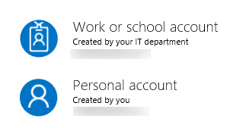

1. Now Navigate to +New option and from there select Networking and Virtual Network.

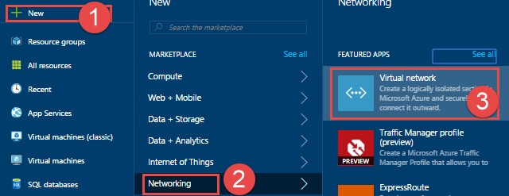

1. Now click on Create,

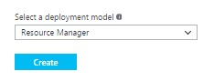

1. Now Fill in the details as below

* Name: Type the name you want to provide for the Virtual Network
* Address Space: Choose an address space according to your need along with the proper CIDR such that it is non-overlapping
* Subnet Name: Choose an appropriate name for subnet.
* Subnet address Range: Create a Subnet with the proper CIDR block such that it is non-overlapping.
* Resource Group: Create a new resource group or select if you have an existing one.
* Location: Select the location where you want the Virtual Network to be placed.

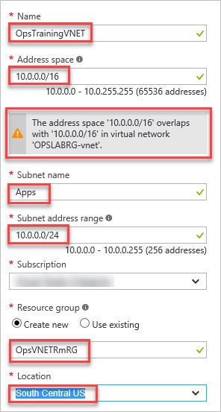

1. Once the details for the Vnet is filled click on Create and proceed.

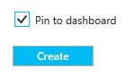

1. Once the Virtual Network is created, Go to +New >Compute, and from Compute select the VM to be deployed.(i.e. Windows, Linux, RHEL, UBUNTU etc..)

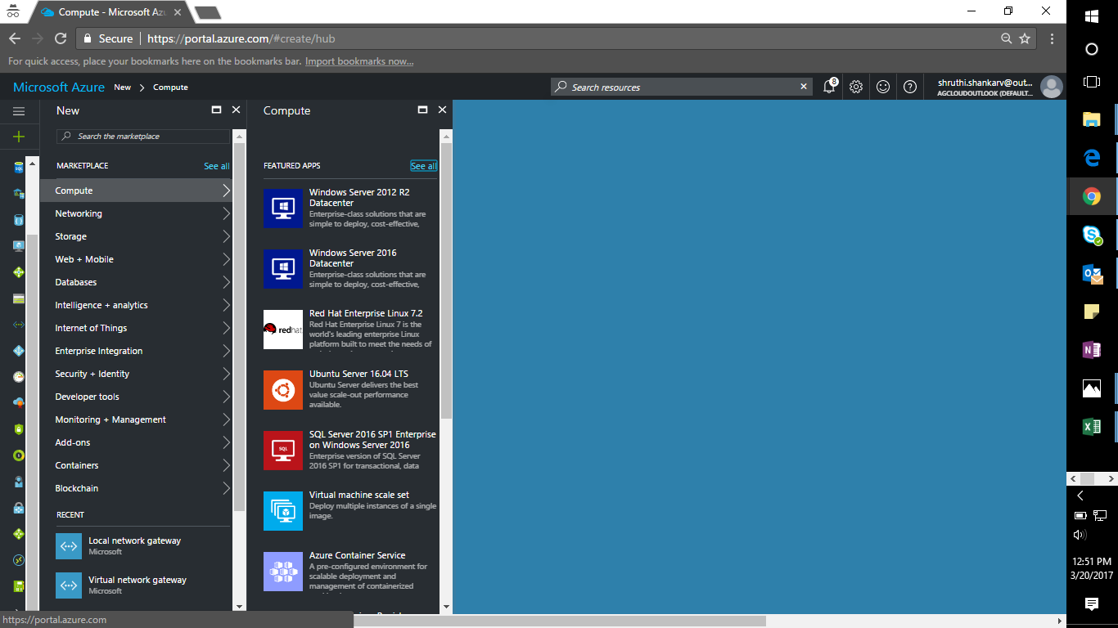

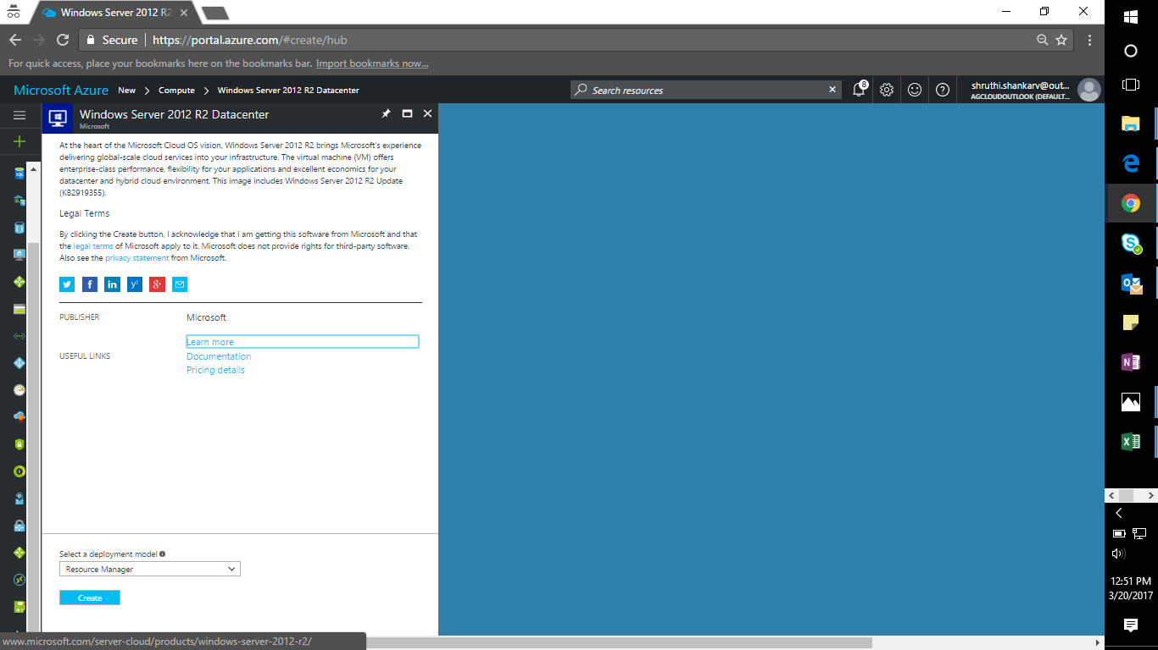

1. After Selecting the Virtual Machine to be deployed, fill in the details as below and proceed further.
   1. Name: Give a Unique name to the VM.
   2. VM disk type: Select the type of the Virtual Machine Disk i.e. HDD/SSD
   3. Username & Password: Specify the username and Password for the VM.
   4. Subscription: Select the Subscription in case you own multiple.
   5. Resource Group: Select the appropriate Resource Group for theVM
   6. Location: Select a region where your VM has to be hosted in.

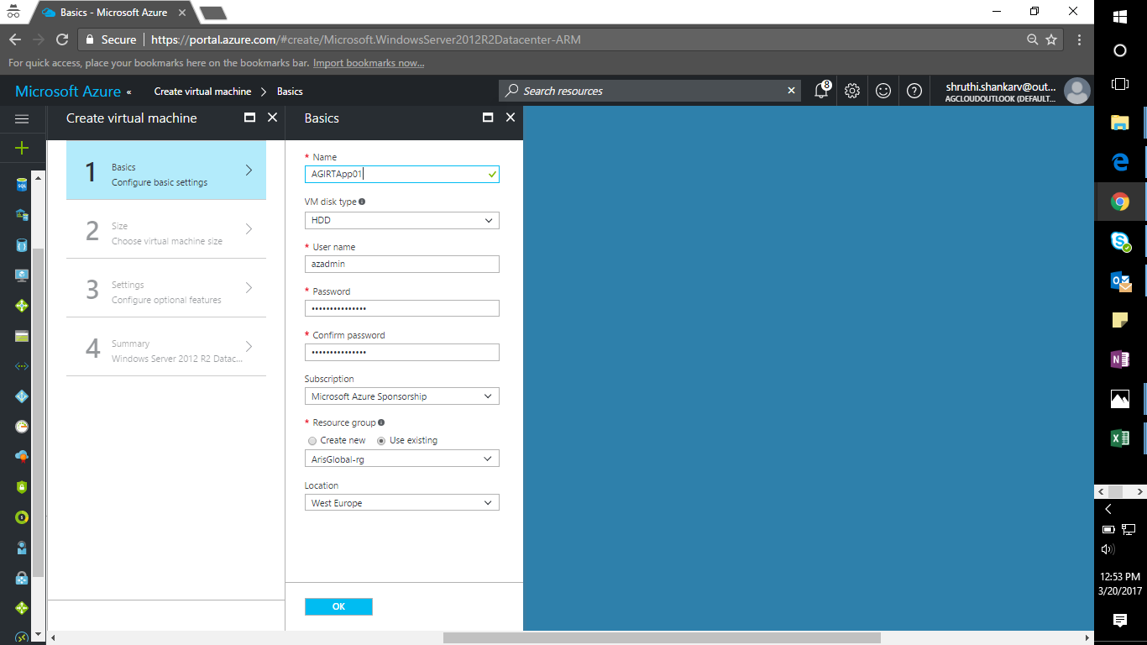

1. Now Click on Next, and select the size for the Virtual Machine according to the need.
2. Now specify the following configuration details.

* Virtual Network: Select the earlier create Virtual Network.
* Subnet: Once the Vnet is selected the associated Subnet for the Vnet will automatically get selected.
* Network Security Group: Leave the NSG as default and then proceed further.
* Availability Set: Create an availability set in case you want multiple VMs to be hosted and placed certain FDs and UDs.
* Now click on create.

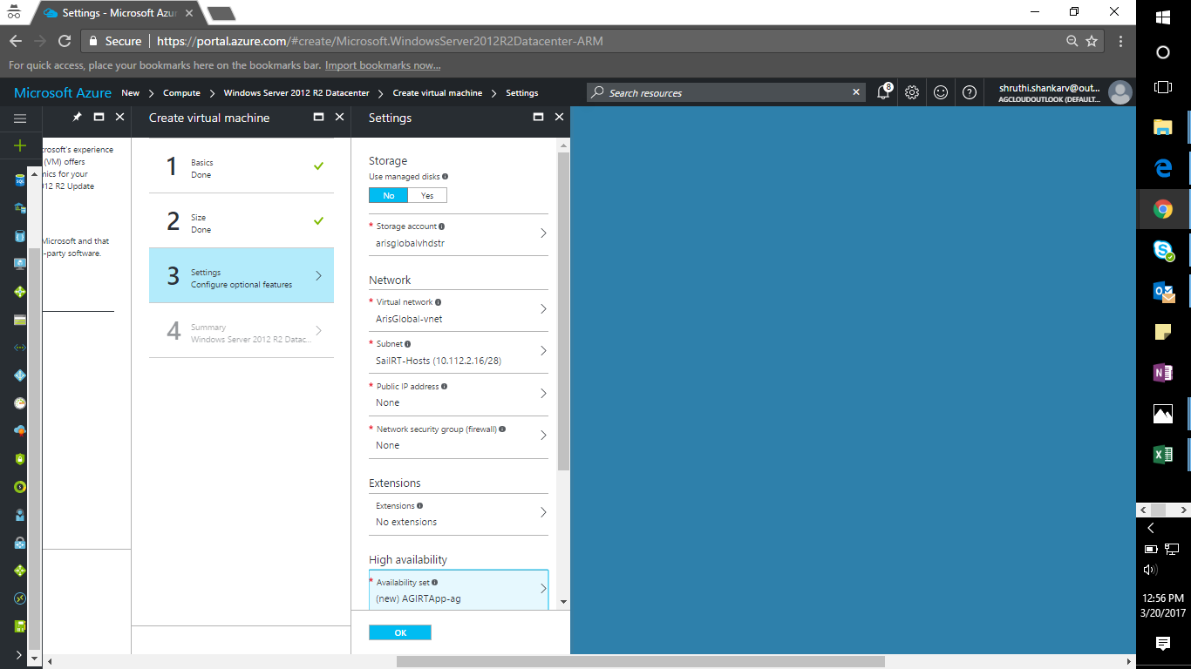

1. Click on OK and you can see that the VM has been deployed.